My Poultry Project

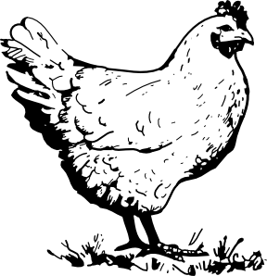
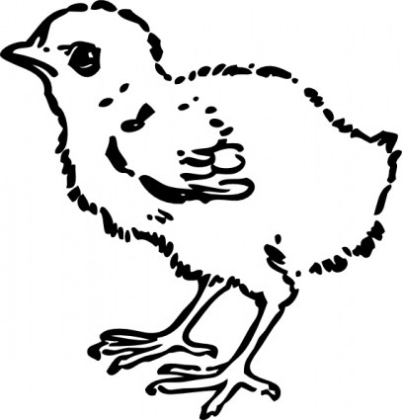
(13-15 year olds)

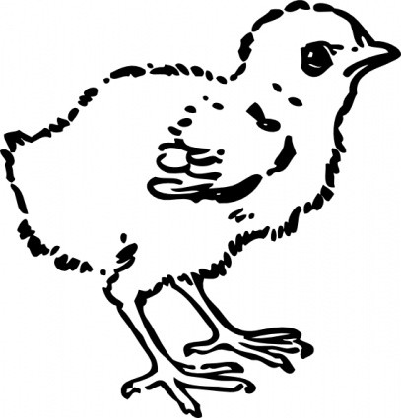

Name:
Age:
County: ______________________________
Address: ______________________________________________________________
Phone_________________________________________________________________

North Carolina State University and North Carolina A&T State University commit themselves to positive action to secure equal opportunity regardless of race, color, religion, creed, national origin, sex, age, disability, or veteran’s status. In addition, the two Universities welcome all person without regard to sexual orientation. North Carolina State University, North Carolina A&T State University, U.S. Department of Agriculture, and local governments cooperating.

Objectives of the Poultry Project Record book

- To gain experiences caring for poultry
- To learn responsibility
- To participate in group activities within a 4-H club
- To learn record keeping skills

Things to keep in mind about the Project:

- This project is for the child to explore and discover project areas.
- This project record book will be judged and placed in a 4-H activity.
- Participants are highly encouraged to participate at the poultry show in a class appropriate to age group.
- The responsibility of animal ownership should not lie solely with the child, but with the parents also.
- The safety of the child should be the primary concern of this project.

Rules of activity:

- Record keeping is from the date of receiving the animal until date of show.
- All project record book and activity books should be turned into the county4-H agent no later than the due date.
- All signatures must be obtained on the front of the record book.
- All work must be done by the submitting 4-H member. Plagiarism is not allowed. Project record books that appear to be plagiarized will be disqualified and ineligible for awards.
- Youth must pick only one chicken to show at the show in October.
- Record books will be judged in their appropriate age categories based on neatness, creativity, involvement in project, and other factors.

Information on my Project animal(s)

- What is your chicken name? _______________________________________________________
- What breed is your chicken? _______________________________________________________
- Is your chicken a Cockerel or puller/rooster or hen? _______________________________________________________
- What does your chicken eat? _______________________________________________________
- What is your chickens age? _______________________________________________________
- What are two things chickens are used for? __________________________________________________________________________________________________________________________________________________
- Name two characteristics of each of the following chicken breeds:
  - Rhode Island Red ________________________________________________________________________________________________________________________________________
  - Barred Rock ________________________________________________________________________________________________________________________________________
  - Skiley
________________________________________________________________________________________________________________________________________

- List Two things you learned about chickens:
  - ________________________________________________________________________________________________________________________________________
  - ________________________________________________________________________________________________________________________________________

Animal Care and Management

Your project requires care and management. List the things necessary to take care of your project animal(s).
Include the following:
Feeding and watering practices
Grooming (clipping, trimming, foot care, etc….)
Health practices and medicines
General management (cleaning living area and feed pan, training, etc….)

Daily- Things done every day
Example: cleaned feed and water containers

Weekly- Things done once a week
Example: cleaned fee and water containers

Monthly- Things done once a month
Example: New bedding

Yearly- Things done one time or occasionally throughout the year
Example: disinfect cages

Parts of a Chicken

Color and label the parts of the chicken

Beak eye breast hock comb shank earlobe toes vent wattles shoulder

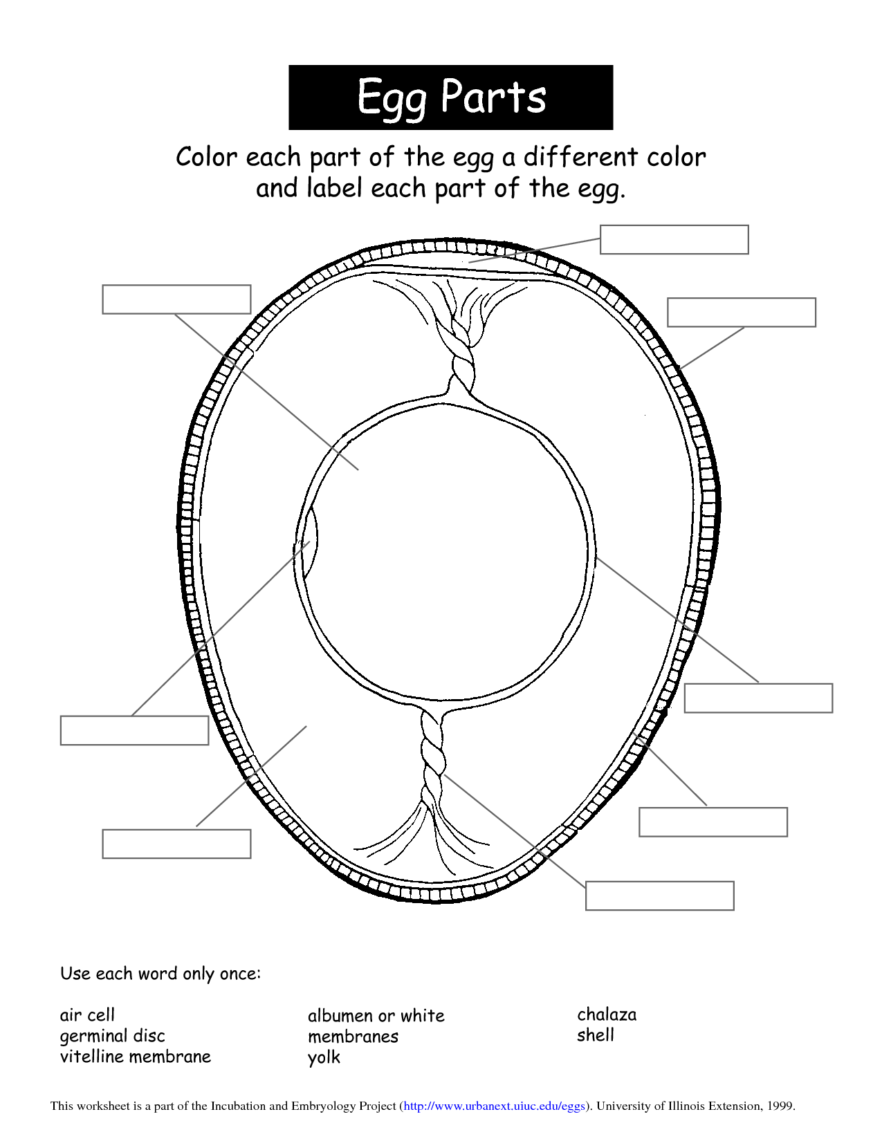

Feeding Poultry

All animals need good nutrition and fresh water every day. Nutrition means getting the right kind of food in the right amount at the right time to keep healthy. Using commercial poultry rations is the best way to be sure your poultry get a nutritionally balanced diet. As birds grow, their diets change. They will require less protein and more starch as they get older. Reading the rations on the feed label will let you know what is the best feed for the type of poultry you are raising.

What is the name of the food you feed your poultry? ___________________________________________________________________
What are the top 3 ingredients? ___________________________________________________________________
What nutrition does it contain? __________________________________________________________________
How much do you feed your birds a day? __________________________________________________________________
A bag of feed costs _______________________________________ and weights ____________________

Draw or place a picture of you feeding your birds.

My 4-H Poultry Project story

The motto of 4-H is “Learn by doing” each year will learn something new by participating in a
4-H project. Please write a story that explains:
- your learning experience with your project.
- what your bird has taught you
- new skills you have gained over this project
- goals and accomplishment. Include details about any shows or exhibits you went to, and ribbons or awards you won.
Other examples that you may consider writing about include: Something that happened that was funny, sad or exciting. Challenges you faced and how you overcame them, who helped you with your project and how they contributed. Things you are most proud of. Feel free to relate your 4-H experience to other parts of your life (school, home, family, friends, etc….). Stories must be at least five sentences.
______________________________________________________________________________________________________________________________________________________________________________________________________________________________________________________________________________________________________________________________________________________________________________________________________________________________________________________________________________________________________________________________________________________________________________________________________________________________________________________________________________________________________________________________________________________________________________________________________________________________________________________________________________________________________________________________________________________________________________________________________________________________________________________________________________________________________________________________________________________________________________________________________________________________________________________________________________________________________________________________________________________________________________________________________________________________________________________________________________________________________________________________________________________________________________________________________________________________________________________________________________________________________________________________________________________________________________________________________________________________________________________________________________________________________________________________________________________________________________________________________________________________________________________________________________________________________________________________________________________________________________________________________________________________________________________________________________________________________________________________________________________________________________________________________________________________________________________________________________________________________________________________________________________________________________________________________________________________________________________________________________________________________________________________________________________________________________________________________________________________________________________________________________________________________________________________________________________________________________________________________________________________________________________________________________________________________________________________________________________________________________________________________________________________________________________________________________________________________________________________________________________________________________________________________________________________________________________________________________________________________________________________________________________________________________________________________________________________________________________________________________________________________________________________________________________________________________________________________________________________________________________________________________________________________________________________________________________________________________________________________________________________________________________________________________________________________________________________________________________________________________________________________________________________________________________________________________________________________________________________________________________________________________________________________________________________________________________________________________________________________________________________________________________________________________________________________________________________________________________________________________________________________________________________________________________________________________________________________________________________________________________________________________________________________________________________________________________________________________
What I did in this project year
The following page is where you can list what you did in this 4-H project. Don’t forget to include these types of 4-H events and activities you might have done this year:
- Events participated in, summer fun, judging teams, county contests
- Leadership roles such as offices held, committees led
- Special meetings & clinics
- Community service
- Public speaking/presentations
- Field trips/camps
- County &/or state fair contest
- Awards or recognition earned
- Shows & competitions; if competing in competitions you should keep records of the results.

Please feel free to add additional pages if necessary.
Name of event/ activity | Date & location | What I did | Level (club, county, state, national) | Award or Recognition earned?
Example: Club Meeting | Sept 6^{th,} 4-H office | Attended the 4-H poultry meeting learning about eggs. | County level | none

A photo of your project animal is to be attached below. This picture must include a picture of you and your bird.

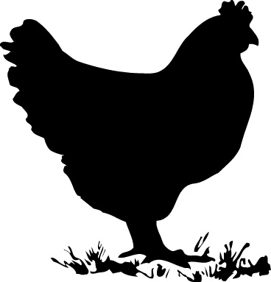

Glossary

Albumen – the white of an egg; the liquid portion surrounding the yolk Beak – the horny mouth part of chickens, turkeys, or other fowl
Bedding – straw, wood shavings, shredded paper, or other materials used to cover the floor of a chicken coop or brooder box to absorb moisture and manure; also called litter

Brood – to sit on or hatch eggs; the chicks themselves

Brooder – a heating device used to imitate the warmth a mother hen gives her chicks

Chalaza – two white cords attached to each side of the yolk to hold the yolk in the center of the egg Chick – a newly hatched chicken of either sex
Cock – adult male fowl Cockerel – a young cock
Coop – a place where chickens are kept

Germ spot or germinal disc – the white spot on the surface of the yolk where the embryo will form Hen – a female chicken one year of age or older
Poultry – domesticated birds kept for eggs or meat Pullet – a female chicken less than one year old Rooster – adult male domestic fowl
Starter feed – the feed for newly hatched poultry

Yolk- The round, yellow portion of an egg

NC Cooperative Extension
Northampton Co. Center
P.O. Box 636
9495 NC Hwy 305
Jackson, NC 27845
Phone: (252)534-2711
Fax: (252)534-1827
http://northampton.ces.ncsu.edu

This 4-H Poultry Project book
was developed and designed by
Sara Villwock 4-H Agent
adapted from Greene County Center’s 4-H
September 2018

