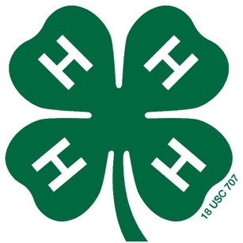
My Clover Pullet Project

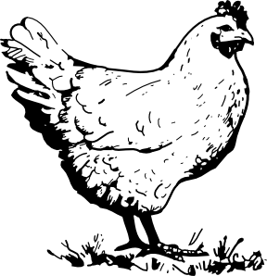
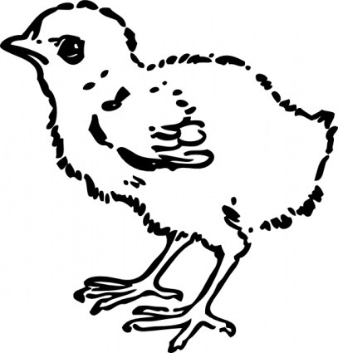
(5-7 year olds)

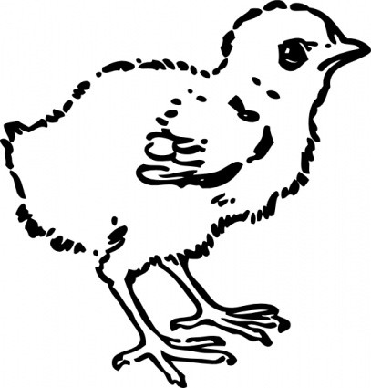

Name:
Age:
County: ______________________________
Address: ______________________________________________________________
Phone_________________________________________________________________

North Carolina State University and North Carolina A&T State University commit themselves to positive action to secure equal opportunity regardless of race, color, religion, creed, national origin, sex, age, disability, or veteran’s status. In addition, the two Universities welcome all person without regard to sexual orientation. North Carolina State University, North Carolina A&T State University, U.S. Department of Agriculture, and local governments cooperating.

Objectives of the Poultry Project Record book

- To gain experiences caring for poultry
- To learn responsibility
- To participate in group activities within a 4-H club
- To learn record keeping skills

Things to keep in mind about the Project:

- This project is for the child to explore and discover project areas.
- This project record book will be judged and placed in a 4-H activity.
- Participants are highly encouraged to participate at the poultry show in a class appropriate to age group.
- The responsibility of animal ownership should not lie solely with the child, but with the parents also.
- The safety of the child should be the primary concern of this project.

Rules of activity:

- Record keeping is from the date of receiving the animal until date of show.
- All project record book and activity books should be turned into the county4-H agent no later than the due date.
- All signatures must be obtained on the front of the record book.
- All work must be done by the submitting 4-H member. Plagiarism is not allowed. Project record books that appear to be plagiarized will be disqualified and ineligible for awards.
- Youth must pick only one chicken to show at the show in October.
- Record books will be judged in their appropriate age categories based on neatness, creativity, involvement in project, and other factors

4-H Pullet Projects for Clovers
“The Incredible Baby Chicks”

My name is _______________________________________________________.
I live in ________________________________________________ County.
I am ___________________________ years old.
I got ____________________________ baby chicks to raise.
They are _________________________________________________________.
I named them _____________________________________________________.

Color this chicken below to make it look like yours.

- Is your chicken a boy ______________ or girl________________.
- Where do you keep your chickens? ___________________________________________________________
- From the items listed below, which one would you feed your chicken. Circle only one answer.
  - Corn
  - Bacon
  - Hay
- Do you collect eggs from your chicken(s)? _________
If so, how many per day? ________
- Did you buy your chicken? _________If so, how much did it cost? _____________

MATCH THE PICTURE WITH THE WORDS:

COMB

SPUR

WATERER

FEEDER

EGG

Match these with the correct answer:

______brooder box A. light to keep chicks warm

______heat source B. use to water baby chicks

___water jar C. use to put feed in for chicks

______feeder try or jar D. what baby chicks eat

______starter feed E. to keep chicks in at first

Find the words listed below and circle them.

A | G | T | H | A | N | D | S | B | U | P | U | F | L | R
V | N | G | H | E | K | Z | W | Y | K | D | Y | E | V | N
H | A | Z | L | Z | G | P | Y | O | P | M | M | E | T | T
R | M | M | M | E | U | G | R | L | E | H | B | D | A | R
T | C | Q | L | S | A | E | S | K | G | B | E | E | Z | A
U | A | V | T | J | D | R | X | B | R | A | A | R | Z | E
R | R | I | M | O | Q | V | N | J | E | M | K | E | K | H
K | E | S | O | R | O | O | S | T | T | Y | R | D | M | Z
E | I | R | G | F | F | N | J | J | S | R | H | B | P | Y
Y | B | E | A | N | E | H | O | B | O | T | C | N | U | O
S | H | E | A | D | J | F | G | O | O | L | C | M | L | Z
T | V | S | K | C | I | H | C | K | R | U | O | F | L | M
X | N | L | D | K | C | U | D | C | H | O | O | D | E | I
N | H | T | L | A | E | H | V | I | L | P | P | Z | T | X
G | E | Q | B | H | W | R | N | E | S | T | A | H | S | B

Beak  Brooder | Feeder  Hands | Nest Hen  Eggs Turkey  Poultry
Care | Head | Pullets Duck
Chicks | Health | Roost Learn
Coop | Heart | Rooster Yolk
Duck | Hen | Turkeys Eggs

Sharing How to Care for my Baby Chicks:
Johnny has learned a lot about doing his 4-H Poultry project. He has written a story about how he cares for his baby chicks, but he needs your help to fill in the correct answers to complete the story. Use the word bank below to fill in the blanks.
Lamp/light Water 4-H straw/shredded paper

6 to 8 week Feed brooder box legs coop

Egg baby chicks 20 to 22 weeks old Pullets

I feed my ________________ several times each day while they are young. They eat_________________, a special feed that I get from the feed store. They need clean _______________________ to drink at all times. Until they are a few weeks old, I keep them in a _____________ __________ with a_____________________ to keep them warm. I use ________________________ for bedding and keep it clean daily. I do not use slippery paper because it will cause them to slip and hurt their ______________. When my chicks are older, I will put them outside in a fenced yard with a chicken _________________ for them to roost at night. You need to feed them a good medicated starter feed for the first __________ then change to a chick growth feed until they start laying around___________. The _______________ (female chicks, not yet a year old) will begin to lay eggs and will need a nesting box. Four or five pullets (or hens) will use the same nest. They grow very fast! I really like to spend time with my chickens. I like to learn all I can about chickens to make my ____________ project a success. I plan to show some of my chickens at out 4-H Poultry Show this fall. I can’t wait until they are 20 to 22 weeks old and start laying ______________. We may use some, share some, and sell some.

Draw a line to the correct part of the chick below then color it.

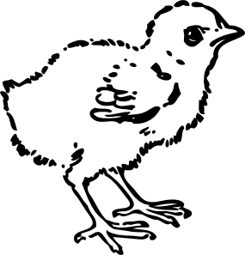
Breast

Back
Wing

Toe
Head

Beak

Eye

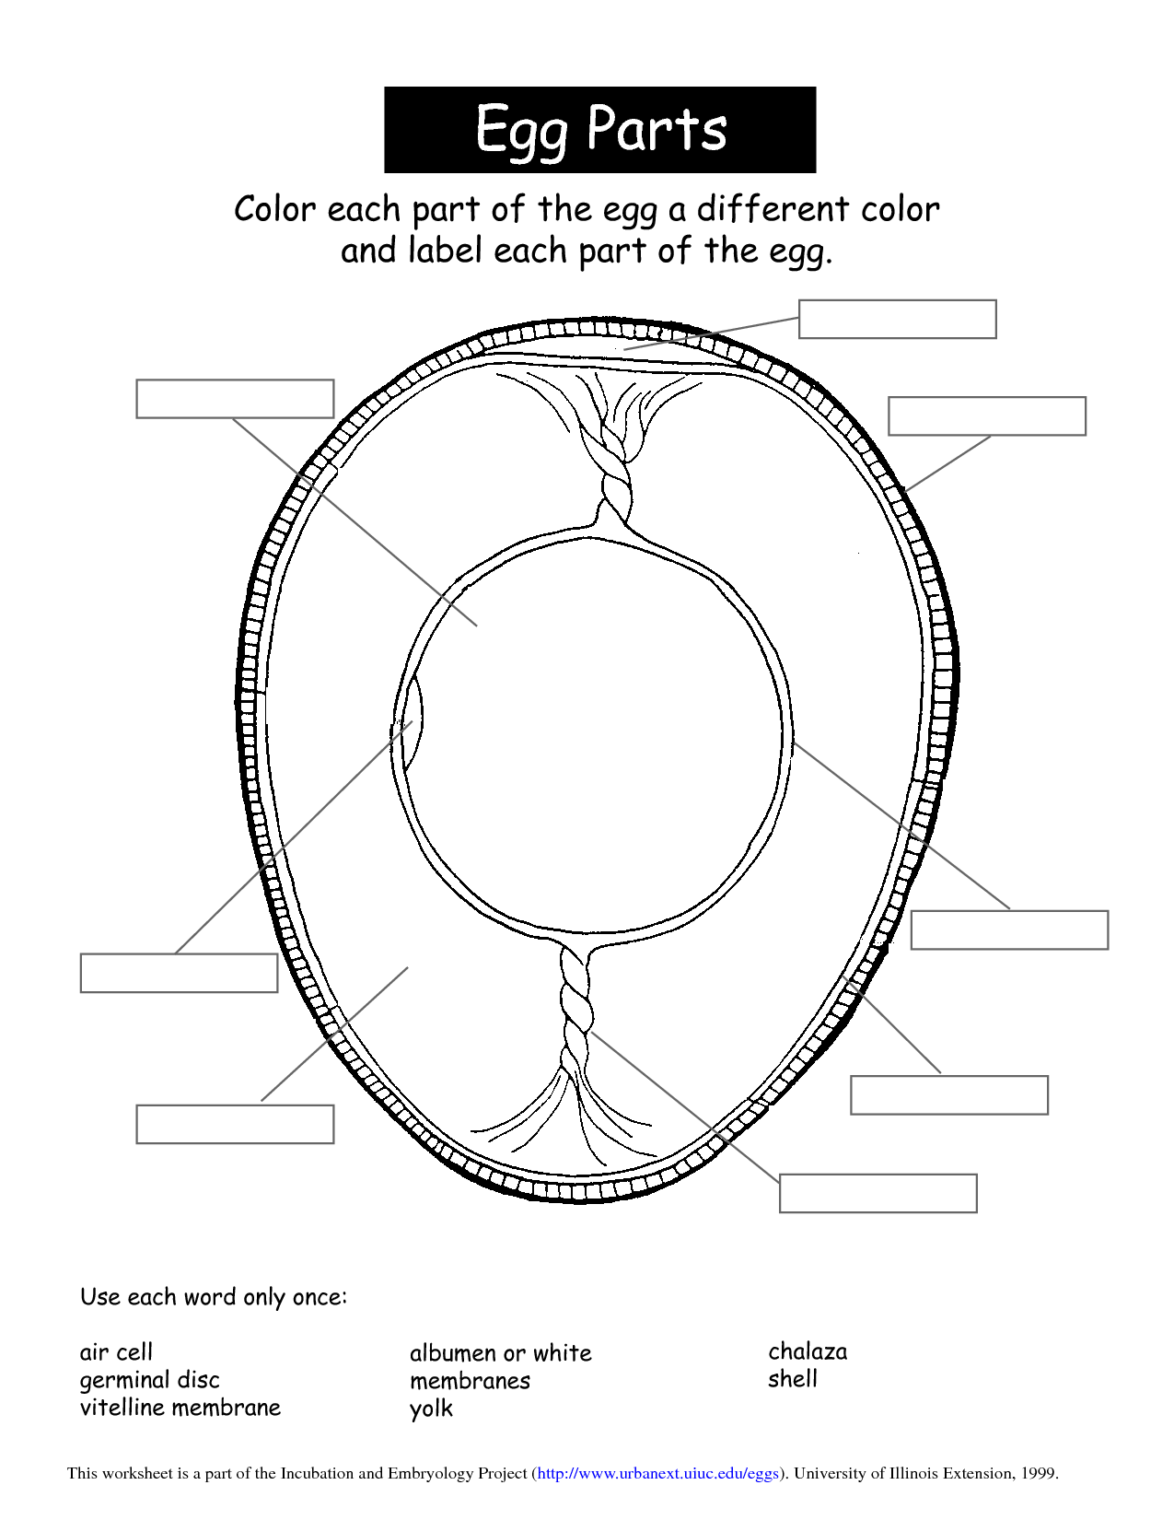

A Good Showman’s Checklist:
- Pick your best hen for the show
- Know what breed your chickens are
- Know what you feed them
- Know where the beak, wing, leg, breast, and comb of your chickens are located
- Know where you keep your chickens… in a coop or fenced yard
- Complete your 4-H Project book
- Remember to have fun as you learn to care for your chickens
- Do your best…. To make the best better!!!!

Below and on the next few pages’ place picture of you and your chickens.

Fun things I did:
Things you and your helper have done in this project book. Discuss each activity and check the ones you did.

- We read the information from the poultry project guide
- I learned about keeping my chicks in a brooder box
- I learned how to fee and water my baby chicks
- I learned how to handle my chicks safely and correctly
- I completed the poultry find-a word page
- I completed the caring for my baby chicks story
- I completed the where my chicks came from activity
- I took pictures of my chicks
- I completed the good showman checklist
- I shared what I learned with friends and family
- I took a trip to visit poultry at the fair
- I read a book about poultry
- I practiced showing my chickens
- I learned about different breeds of chickens

Glossary

Albumen – the white of an egg; the liquid portion surrounding the yolk Beak – the horny mouth part of chickens, turkeys, or other fowl
Bedding – straw, wood shavings, shredded paper, or other materials used to cover the floor of a chicken coop or brooder box to absorb moisture and manure; also called litter

Brood – to sit on or hatch eggs; the chicks themselves

Brooder – a heating device used to imitate the warmth a mother hen gives her chicks

Chalaza – two white cords attached to each side of the yolk to hold the yolk in the center of the egg Chick – a newly hatched chicken of either sex
Cock – adult male fowl Cockerel – a young cock
Coop – a place where chickens are kept

Germ spot or germinal disc – the white spot on the surface of the yolk where the embryo will form Hen – a female chicken one year of age or older
Poultry – domesticated birds kept for eggs or meat Pullet – a female chicken less than one year old Rooster – adult male domestic fowl
Starter feed – the feed for newly hatched poultry

Yolk- The round, yellow portion of an egg

NC Cooperative Extension
Northampton Co. Center
P.O. Box 636
9495 NC Hwy 305
Jackson, NC 27845
Phone: (252)534-2711
Fax: (252)534-1827
http://northampton.ces.ncsu.edu

This Cloverbud 4-H Poultry Project book
was developed and designed by
Sara Villwock 4-H Agent
adapted from Warren County Center’s 4-H members Joseph and Jane Carpenter.
September 2018

