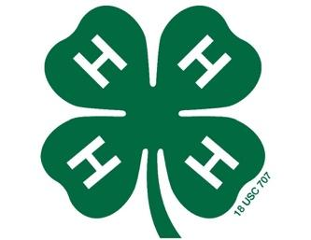
Northampton County 4-H Poultry Show
Rules and Regulations

- Participant must be between the ages of 5 – 18, as of January 1, 2018 and enroll or be a current Participant in Northampton county 4-H.

- Participants are strongly encouraged to attend the two of the 4 recommended * workshops. Participating families that attend will receive pertinent information and publications on raising backyard flocks and to learn procedures of the poultry project.

June TBA
Receiving chicks and caring for chicks

June 27, 2019 @ 6:00pm

August 1, 2019@ 6:00pm

August 22, 2019 @6:00pm

September 26, 2019 @ 6:00pm

Show
October 10, 2019th @ 6:00pm

Workshops Will Be Held at:
Northampton County Cooperative Extension Service
9495 NC Hwy 305
Jackson, NC 27845

- Each participant will receive of two female chicks of brown egg-laying breeds, approximately the same age. You will get your Chicks and starter kits sometime in mid June. The date and time will be sent to you.
- Participant will raise the chicks until the Northampton County 4-H Poultry Show on October 10, 2019 under the supervision of the guardians and Extension Agents.
- Participants will be given a “starter kit” to take home with their chicks but will be responsible for all expenses incurred while raising them (feed, housing, medication, etc.) to complete the project.

- Participant will present one bird at the Northampton County 4-H Poultry Show on Thursday, October 10, 2019 at the Jackson Farmers Market. Divisions will be divided according to 4-H ages of Little Britches (4 and under), Cloverbuds (5-7), Juniors (8-12) and Seniors (13-18). A qualified adult or youth will judge the show.
- A 4-H Poultry Record Book must be completed and turned in before the bird can be exhibited at the 4-H Poultry Show. Record books are due October 10, 2019 to be on display at the show.
- All decisions by the judge are final. Direct criticism or interference with the judge, show or livestock show management, other exhibitors, breed representatives, or show officials before, during, or after the competitive event is prohibited. In the furtherance of their official duty, all judges, show, and livestock show management, or other show officials shall be treated with courtesy, cooperation and respect and no person shall direct abusive or threatening conduct toward them. Potential disqualification from future events after review is possible.
- Entry fees are $20.00 per participant with chicks and starter kit, $8 if using your already owned chicken. Entry fees are due with entry forms. Entry deadline is June 7, 2019 by 5:00 pm to the Northampton County Extension office.

Please do not hesitate to contact the Northampton County Cooperative Extension Office at (252) 534-2711 with any questions:

Sara Villwock Ann Lawrence
4-H Agent 4-H Program Assistant
sara_villwock@ncsu.edu ann_lawrence@ncsu.edu

Beth Burchell
Livestock Agent
beth_burchell@ncsu.edu

