North Carolina 4-H
Re-Enrolling in 4-H Online
Northampton County

UPDATING A 4-H ONLINE PROFILE
4-H requires annual updates of membership information within our 4-H Online system. 4-H Online is the North Carolina 4-H Enrollment and event registration program. If you have an existing Family Profile, please take a few minutes to review and make any necessary updates (new address, emergency contact information, medical information) during the re-enrollment period. The website can be found at https://nc.4honline.com

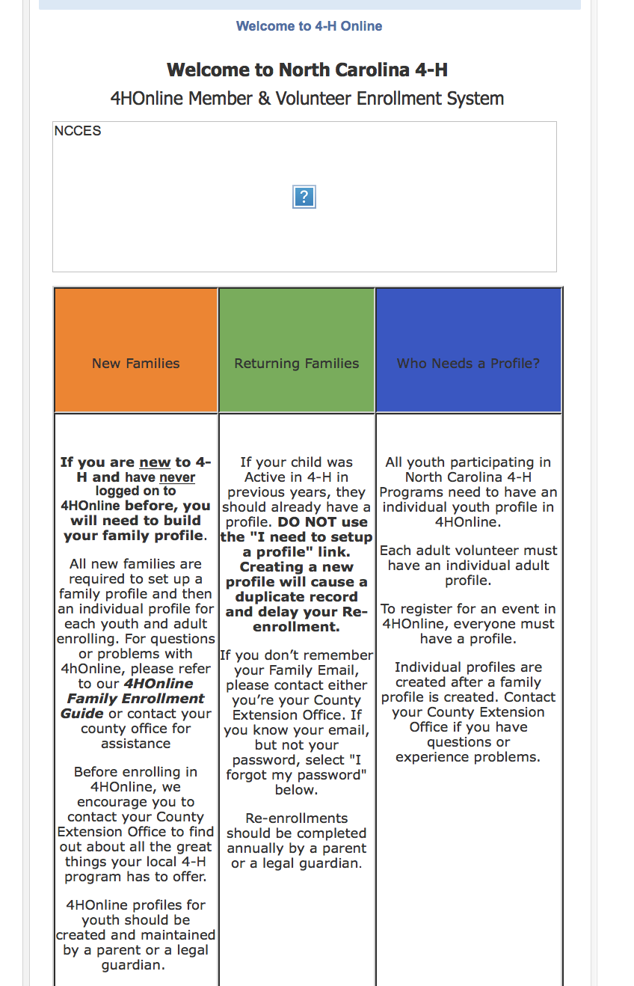
HOW TO RE-ENROLL
- This is what the login screen looks like
- 4-H members and volunteers must re-enroll in 4-H Online ANNUALLY
- On or after January 1 of each year, go to the 4-H Online login screen at https://nc.4honline.com
- Log in to your family account. If you forgot your password, click “I forgot my password” and follow the instructions. If you know you have an account but cannot remember the email address associated with your account, contact your 4-H Agent.
- Review and update the information for each youth and/or adult in your family
  - Click on the “Edit” tab to access youth/ volunteer personal information. Click “Enroll” for current 4-H year
  - Continue through your profile and make any necessary changes and/ or updates
  - Health information and 4-H authorizations (Photo Release, Volunteer Screening, etc.) must be updated annually
  - When you’ve made all necessary updates – click, “Submit Enrollment”

Once your enrollment has been submitted, it will be sent to the Extension Office to be approved. You should get an email back indicating your enrollment has been submitted. If there are any problems with your enrollment, you will get an e-mail with instructions for correcting those issues. If there are no problems, you will receive an e-mail stating that you have been accepted and will have access to your enrollment to make updates throughout the year.

We encourage you to keep your login (email and password) written down in a secure location. This way, you can access your 4-H Online profile whenever you need to.

If you have any questions, contact the Extension Office at 252-534-2711

